IIS CONNECTION:
- Start IIS Manager
- In Default Web site right click and add application
- 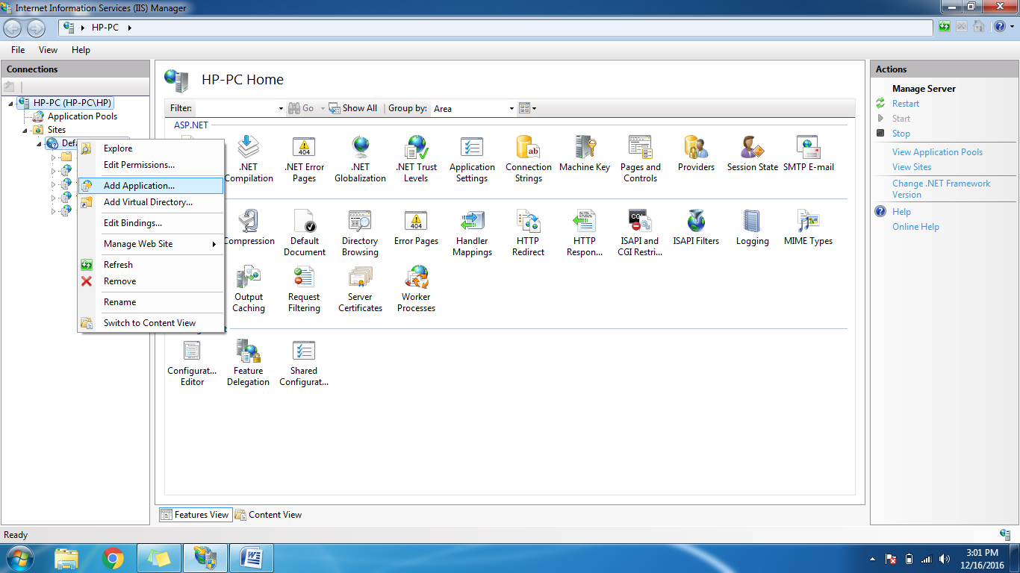
- Add physical path of project (Ex: D:/Projects/carwayfare)
- 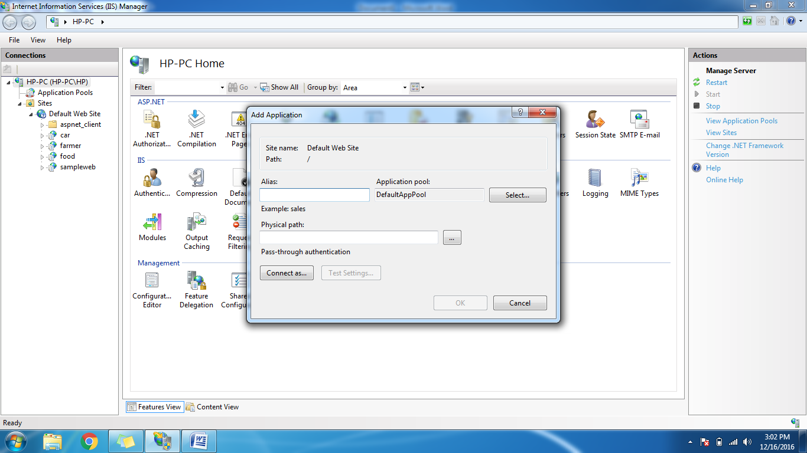
- Add alias name which is most important since it should be given in browser
- After adding go to command promp and type ipconfig
- Note the IPV4 address
- Type in browser as 192.168.43.227/car/index.aspx (192.168.43.227 is IPV4 address)
- The project will be displayed in connected network ☺.

NOTE:

- For enabling iis go to program and features and click turn windows program on and off and enable the needed sources.
- In iis for application pool v4.0. run the cmd as admin and install by using the following command. (START>ACCESSORIES>CMD – Open as admin)
